Higher Realms of Prayer and Sacrifice
June 26, 2016
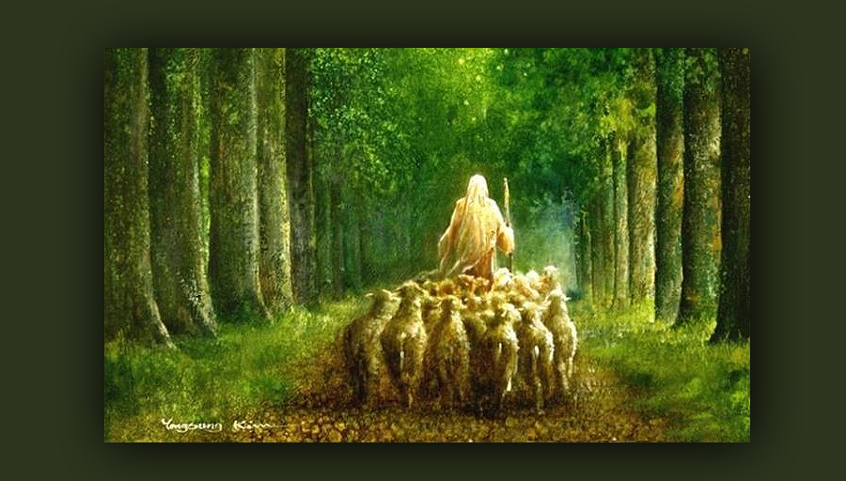
The Lord Jesus is guiding and forming us, Heartdwellers. May we receive His wisdom and patience with gratitude and perseverance.

Carol and I had a conversation about the continuing stability of the world, despite threats from wars and rumors of wars. The Lord has told us minute-by-minute, but it is dragging on. Things ramp up and it looks like war is about to erupt, then things cool off. No war yet. And though we prayed for mercy, we didn’t expect mercy???

Carol was asking the Lord if He would keep us here until Trump was in office and He began speaking to her, “I do not want you to fear, or relax the vigil of prayer. And this tension of wondering will help you. DO NOT relax into thinking you may have yet another 4 months.”

Oh, how foolish we are, guys. Oh, how foolish we are... Here is mercy, a reprieve, nations backing down again. Each time they ramp up right to the edge, and then they back down again. But the Lord continues to keep us on the edge!

Lord, truly what is going on and what do I tell them?

I heard His voice immediately, “Tell them I am waiting. There is a groundswell of conversions going on in this moment as countries are waking up to the agenda of the New World Order. There are pockets of conversions going on that are beginning to swell and take with them those around them. As this is happening, it is not the time for any dramatic change. I have told you, you would have peace that you have done all you could do when the time came.

“Have you had this peace, Clare?”

No, Lord, in fact I've made a mental note. I have not.

“The world is beginning to see that politics without God are more entrapping than politics with God. Pres. Putin has been better to his people than Pres. Obama. Waking up from communism and embracing the moral standards of the Faith, protecting the concept of family and nurturing her people. Giving the poor opportunities, building bunkers for her population…preventing Sharia law. While Obama is counting on the decimation of the masses without protection from nuclear war, and allowing America’s laws to be changed by Muslims.”

Lord, I don’t understand. You have said this was scripted, yet Putin’s spoken agendas are far different than Obama’s. I don’t get it.

“I have told you before, Dear One, Pres. Putin is not a free agent. If he were, things would be different. The overthrow of the Elite is the next thing on My agenda. As the peoples of the world wake up to the manipulation, slaughter and total disregard for the lives of the common man; as they wake up, they can and will overthrow this evil force.
"More and more from higher levels are falling out of agreement with the plans to annihilate the populations of the world. More and more in very high levels are beginning to see: what they have planned to end others, will in fact be their own demise. This is the effect of your prayers.

“As we stay on the edge of our seats, interceding, massive movements are beginning to emerge. Those who were with the agenda are turning away and joining others in a counter-movement.”

I asked Him: Does this mean the whole world will convert?

“I wish…” He said wistfully. “There are still plenty with controlling, greedy agendas completely in league with the devil. It will be a battle, a big battle. But I am with those who are with Me. Though they be outnumbered, I am on their side, doing things that will give them an advantage over their enemies.

“I am for what is right and good. I am for a people who are fully awake to their sins and know they have opened the door to this oppression by their worldliness. They have only to repent and pay attention to Me and what is really going on. Your world has been so consumed with Capitalism and acquisition, they sided with whoever could give them the most ‘bang for their buck’ as the idiom goes.

“Now they are seeing how counter-productive that actually is playing out to be. In short, they are waking up to their insatiable lust for power and wealth and seeing that what lies before them is a wasteland of their indifference, created by manipulation and greed…’Give me my candy and I’ll vote for you.’

“While secular humanism, which holds to the ideals of Satanism, has won over the minds of leaders in the past, they are now seeing the continuing opportunity for a one world dictator is very dangerous."

At this point, my eyes were starting to close involuntarily. I said, “Lord, I am so tired.”

He answered me, “This is a start a good start on the message. Go to bed.” That was around 2:00am in the morning...

An hour later and I’m back and bushy-tailed. I began to discern and double-check discernment on the first half of this message. I have been feeling a little torn between what is happening in the political world that might impact the salvation of souls, and the continuing word of the Lord that it could begin at any moment. That seems so counter-productive to getting Mr. Trump in office. I received the confirmation I was looking for, that the first part of this message is indeed Jesus speaking to me. You know, I worry because sometimes my pride...sometimes He has to discipline my pride by letting me fail in discernment. So, I try to be very careful.

And He began speaking in that moment. “Clare, you have continued to be vigilant to lower yourself, and this lowliness has brought about My fidelity in speaking through you.”

Oh, Lord, I weep at the sight of my sins and unworthiness. I feel so riddled through with pride and judgment. I positively hate those thoughts, and that part of my character.

“And that hatred is half the battle. Keep calling on Me, Clare, keep calling on Me. Your continuing prayers to be lower and lower keep Me coming back and fine-tuning you. Oh, how pleasing these prayers are to Me. If only My people knew how powerful meekness is before Me and the citizens of Heaven.”

Lord, I want to be little, please keep helping me to be little. And I miss our times together, Jesus. I miss You.

I said this because lately I’ve grown a little tired with my wonderful worship list … and felt the need for what I call ’Sacred Silence’ and just being still before Him. So, I haven’t had the kind of worship experiences that include music; I have preferred the silence. And Jesus has begun speaking to me immediately, so I didn’t really get to dwell in His presence and worship Him.

Just after I said this, I began to feel my head resting against His warm shoulder. And the sweetness of His presence drew me up and out of myself into His tender Love.

He said, “We need this, Clare; you need this, and I need this…truly We have needed this kind of time together."

But now in this moment, all I can do is bask in His presence in total silence, no music or worship with words per se… just the overwhelming sweetness and security of His arms and my longing to shower Him with my gratitude. There is nothing this world has that can even begin to compare with truly loving God.

Well, as I entered deeper and deeper into this Sacred silence, my body relaxed and I began to feel insecure sitting in a chair, so I went to lay down, my head still resting over His heart.

Ezekiel is so sweet - he always honors that. And if I start to get distracted, he said, "Isn't the Lord present to you right now? Don't get distracted!"

So, as I lay there with my head on His shoulder, my mind would wander in and out of His presence…drawn away by silly distractions of the world…silly concerns, thorns actually. And somehow, He would draw me back to that very pure place over His heart.

Finally, I was so relaxed I fell asleep. I awoke at 4:00 and realized I was much too tired to keep going.

So, here I am at 12:00 in the afternoon, wanting very much to hear whatever else He has to say and get it to you, my dear Heartdwelling Family.

This brings me to the struggle I’ve had lately. I’m going to ask all of you to pay particular attention to my words and read the transcript of this when Carol gets it up, because if you don’t pay really close attention to every word, you’re going to misunderstand what I am saying and go off in the wrong direction.

I’ve been perplexed by the Lord’s absolute insistence on intercession, as though the world was ending tomorrow… and yet the continued waiting. I know He said 'minute-by-minute', but lately I’ve been feeling that minute-by-minute is being extended and I haven’t had the peace He spoke of several months ago. At that time, He said something to the effect of, “You will know it is time because you will feel you have done everything that was yours to do, and you will have great peace.” I know what great peace feels like: there's a sense of finality and accomplishment where you can finally let it go and rest in His pleasure that you’ve finished the work given you.

I don’t feel that, dear friends.

Rather I am feeling, “Come on let’s get on with it. Let’s finish up.” Well, this whole idea of minute-by-minute waiting doesn’t exactly make sense to me in light of the world situation. I really believe Mr. Trump is being raised up by God. I really feel that the tide is turning against the Elite and I, in my foolish human reasoning - totally ignorant mind you - really can’t make these two puzzle pieces quite fit together.

So, I'm going back to the conversation I had with Carol. And basically, He said that He wants us all on the edge of our seats, waiting with Him - but pressing in with intercession for the world. And He’s allowing us to feel this urgent calling, because He is ramping us up in prayer.

Heartdwellers, our prayers, combined with others, ARE MAKING A DIFFERENCE!! If He were to tell us that the Rapture was far off, would we be praying this way with so much passion and intensity? Well, no, I wouldn’t be. I’d be more focused on working and even having a little tiny bit of recreation, like an innocent movie once every two weeks. But He has kept us busy nearly every moment of the day.

Now, being totally transparent with you all, because I really want you to get it, I think to myself, ‘Well, one of our listeners told us of a certain popular visionary that said the Rapture was more than a decade away!’ So I’m thinking to myself, ‘What’s up with this, do I have it all wrong? Because it hasn’t happened yet? And Jesus says "any minute?’"

Then I look at Israeli News live, which maybe I shouldn’t look at? Not sure on this one guys. I don't look at any other news sites at all. But I think I might be skating near the edge here.

And the Lord addressed this confusion of mine, my fears about myself and hearing Jesus and Jesus only, clearly, and He did it through the Bible Promises. When I asked Him about Israeli News Live and if I should share one of their videos, I opened to Marriage, and this line stood out, “Drink waters from your own cistern. Flowing waters from your own well.” Proverbs 5:15

This has always meant ‘Don’t drink from other sources.’ That's the history of that Scripture verse.

I truly got it in that moment. Jesus has assembled a group here, a group of heartdwellers who love to rest in His heart. He is forming us in a very specific way, unique to us. And the way in which He is leading us is not just prophetic, but intensely focused on preparing us with the virtues He loves in His Bride.

He continues to stretch us and draw us out and up into higher realms of prayer, self-sacrifice and brotherly love. What He is doing with us is unique to us. What He is doing with other visionaries is unique to them. In other words, don’t be tasting the waters of other wells, don’t be comparing, don’t be questioning. Trust Him that He is indeed filling this well with fresh, anointed, living waters and He is doing it in His own special way, unique to us.

One thing I do know about myself, is that I don’t get really serious unless the situations around me get really serious…then I buckle down. I think that's probably human nature though. And Jesus is getting us to buckle down and expand our horizons. He is taking us into new realms of our own particular crosses in love, prayer and sacrifice. Places where, before, we tended towards indifference, but now we hurt intensely for those destined for Hell.

As we continue to pray, not only are we growing, but a grassroots movement is beginning to emerge against Satan’s plan for the nations. What wonderful fruit from our prayers this is!! Of course, not only our prayers but others as well. Still, we can see with this little well, the Lord is forming us and changing the world and He’s doing it in His own way; imparting understanding to us little by little in a specific way intended for His Heartdwellers and the plans He has for us, now and in Eternity.

So, just to be sure…I didn’t say the Rapture was years or decades off, as some say it is. Rather, I said the Lord wants us on the edge of our seats, putting forth all our best efforts to finish our assignments and pray passionately for those we do not even know…even the nations who are considered our enemies. And pray as if it were ALL going to end tomorrow.

At this point I asked the Lord, 'Do You have You anything to add, Jesus?

“My Brides, it is just as she has said. Again, she has spoken My Heart to you.”

